# CS 255 System Design Document Template

Isaiah Ingraham

8-13-24

This template lays out all the different sections that you need to complete for Project Two. Each section has guidance to prompt your thinking. You will need to continually reference the interview transcript as you work to make sure that you are addressing your client’s needs. There is no required length for the final document. Instead, the goal is to complete each section based on what your client’s needs are. Remove this note when you are finished and replace all bracketed text with the relevant information.

## UML Diagrams

### UML Use Case Diagram

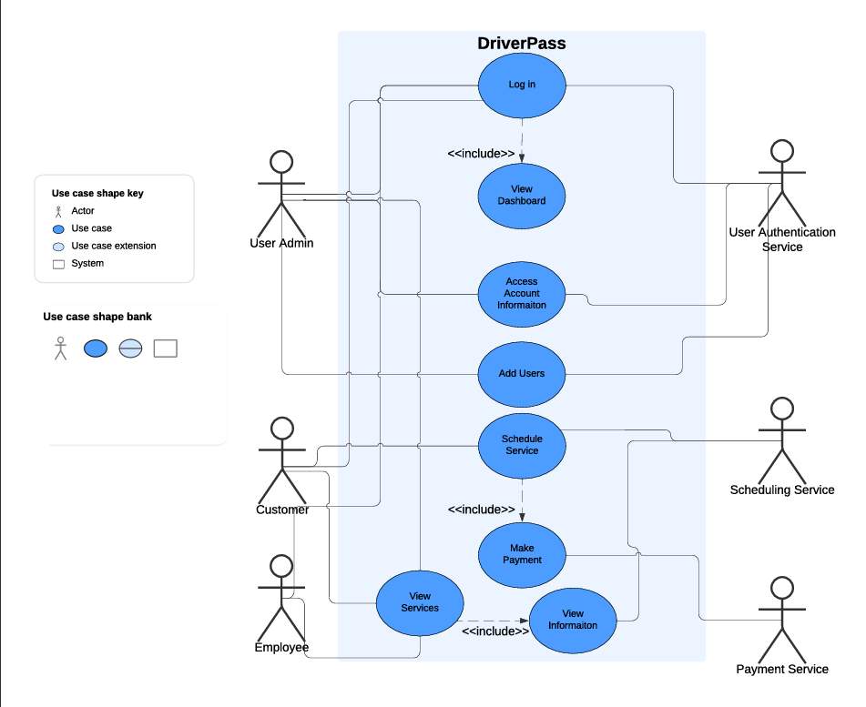

### UML Activity Diagrams

### UML Sequence Diagram

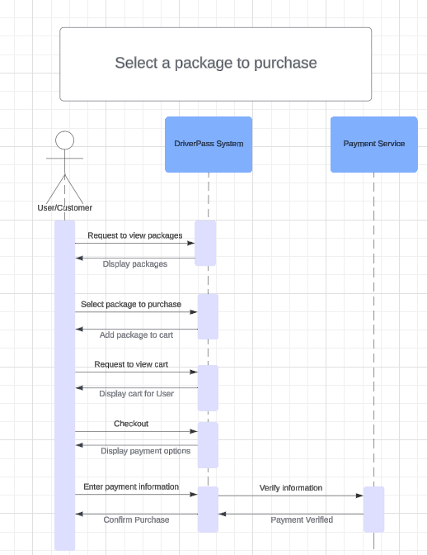

### UML Class Diagram

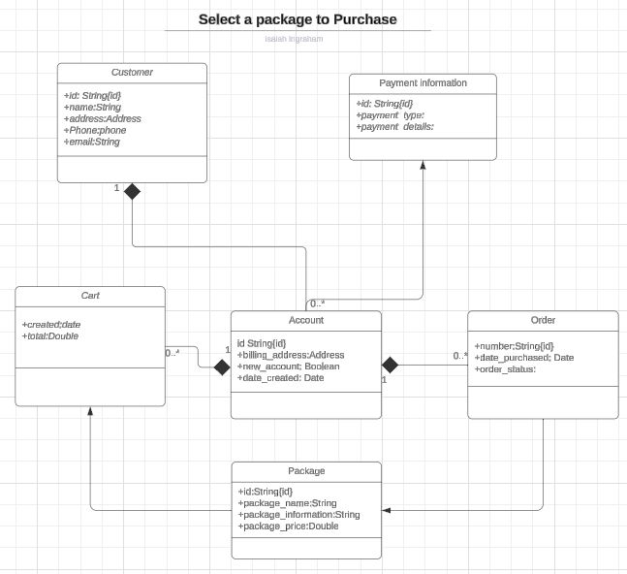

## Technical Requirements

DriverPass application will need a service to host the web application which should be outsourced to a third party to give DriverPass less responsibility and not have to be responsible for server maintenance. DriverPass will also need a database of customers and their account information which will have an authentication service for security for users to log in. Another thing that DriverPass will need is access to an outside payment service. DriverPass also needs access to the DMV for updating the driver laws and requirements. DriverPass needs to also be able to grant User’s permissions to reset Passwords and ability to disable packages.